Worksheet
The Edge Team Training
Module 5 - Session 4

Leading Three Types of People
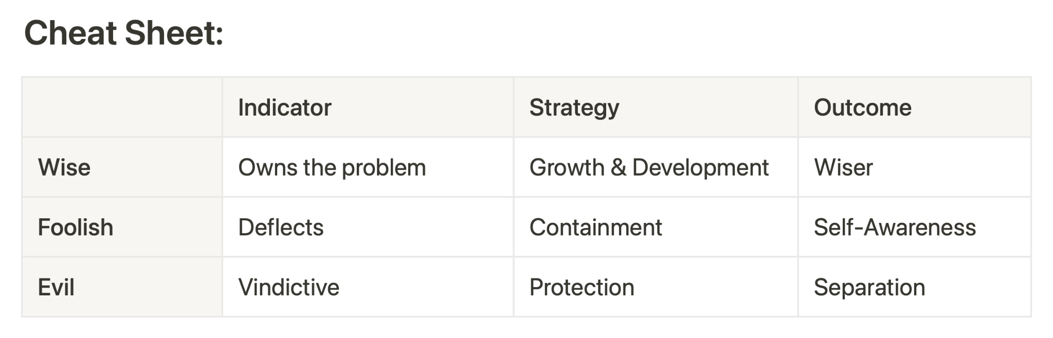
EXERCISE 1. Giving Feedback WISE and FOOLISH
Think of one person this week to whom you can give feedback. Based on the cheat sheet above, plan for the conversation to go either way.
What is your plan if they are “WISE”?

What is your plan if they are “FOOLISH”?

