SUBMISSION PRAYER
-April Chapel, MA, ALC

"Submit to God. Resist the devil, and he will flee from you." James 4:7

This is the formula for spiritual warfare. If satan is eating your lunch, then there is a problem with either step 1, submitting to God, or step 2, resisting the devil.
What has not been surrendered to God? Pain? Offense? Relationships? Trust? Fear? The past? Control? Trauma? Guilt? Unrealized expectations?

Whatever emotion or experience you have little tolerance for, most likely is rooted in woundedness. Sin and trauma wound the soul. If we refuse to submit those wounds to God for healing, we allow the enemy of our souls a legal right to traffic in our thinking, our emotions, and our lives. We come OUT of agreement with the slimy snake who uses our pain as a weapon against us by surrendering our wounds to the authority of the Lord Jesus Christ and the healing work of his Holy Spirit.

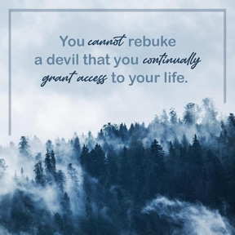

“Father God, right now I come to you and I submit _________________ to You. Jesus, I come into your presence now, and I ask you to surround me. I come under your authority and your claim upon my life. I give myself to you—body, soul, and spirit. I give my heart to you, in every way—including the broken, painful, and misunderstood places in me. I declare Your authority over my heart, for You made my heart and You have redeemed my heart. I give You permission to do what You want with or through me that would glorify You. The rights I previously claimed to be mine, I now acknowledge belong to You and are under Your control. I choose to stop pursuing my rights in my strength. Jesus, forgive me for all my self-protection, self-righteousness, self-condemnation, and self-redemption, and for all my false comforters. Cleanse my heart of every sin by your shed blood. By faith, I take captive every false belief, every difficult memory, and every fear that is causing me distress and submit them to the authority of the Holy Spirit. Reveal, Lord, every way of thinking that is in opposition to Your truth. In the mighty name of Jesus, AMEN.”

